Skills Practice

Probability of Compound Events
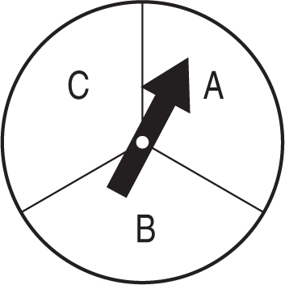
The spinner at the right is spun twice.

1. Draw a tree diagram to represent the situation.

2. What is the probability of getting at least one A?

For each situation, make a tree diagram to show the sample space. Then give the total number of outcomes.

3. choosing a hamburger or hot dog and potato salad or macaroni salad

4. choosing a vowel from the word COMPUTER and a consonant from the word BOOK

5. choosing between the numbers 1, 2 or 3, and the colors blue, red, or green

