Problem-Solving Practice

Theoretical and Experimental Probability

HOBBIES For Exercises 1–4, use the graph of a survey of 24 seventh-grade students asked to name their favorite hobby.
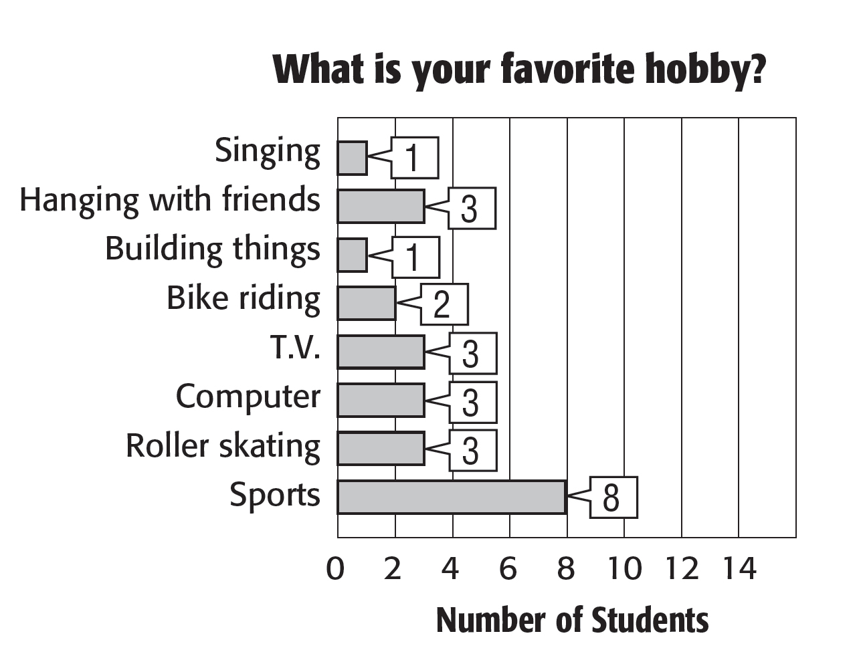

1. What is the probability that a student’s favorite hobby is roller skating? | 2. Suppose 200 seventh-grade students were surveyed. How many can be expected to say that roller skating is their favorite hobby?
3. Suppose 60 seventh-grade students were surveyed. How many can be expected to say that bike riding is their favorite hobby? | 4. Suppose 150 seventh-grade students were surveyed. How many can be expected to say that playing sports is their favorite hobby?

WINTER ACTIVITIES For Exercises 5 and 6, use the graph of a survey with 104 responses in which respondents were asked about their favorite winter activities.
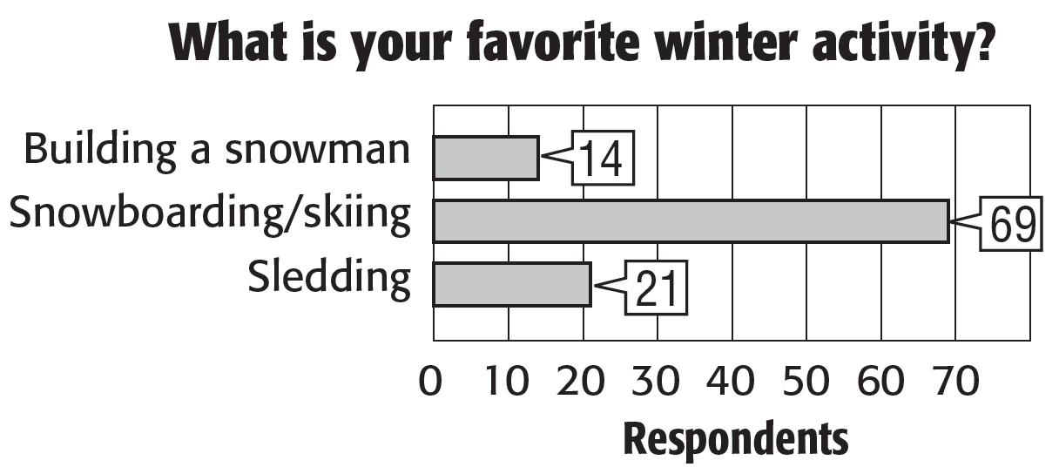

5. What is the probability that someone’s favorite winter activity is building a snowman? Write the probability as a fraction. | 6. If 500 people had responded, how many would have been expected to list sledding as their favorite winter activity? Round to the nearest whole person.

